TVLGA18 Executive Board Meeting
January 6, 2026, 11:00 AM
Welcome Center Conference Room A

Attendees: Jena Feil (past president), Nancy Johnson (president), Kathryn Hughes (VP by phone), Carol Gouty (secretary), Evelyn Brooks (Treasurer), Debbie Petersen (member at large), Pam Wilkiel (membership by phone), Patti Miller (webmaster)
Unable to attend: Julie Langlas (webmaster)
- The meeting was called to order at 11:00 AM by Nancy Johnson.
- 2026 Application
  - A new application is available on our website with the corrected link and will be sent to members. It has an increased handicap fee ($29) and includes the yellow/green combo tee option. There will be no special handicap requirement for the combo tees.
  - Member at Large Debbie Petersen will be responsible for advertising the league.
    - Discussed past advertising strategies including FB, TVPOA emails, New Villagers, and golf shop options including putting flyers in the restrooms of the pro shops. Debbie Petersen will see if the pro shops have the information card that has a bar code to scan for added information and follow up with the other options including Next Door.
    - Cost to order the small information cards is approximately $37 for 500 cards. Patti Miller can order more if desired.
  - Application submission process: Membership Chairman Pam Wilkiel is out of town until February and will process any apps received when she returns. Sue McSherry will pick up any apps in Pam’s mailbox until she returns.
- Changes for 2026-reviewed and approved: motion to approve by Nancy Johnson and seconded by Jena Feil with unanimous approval.
  - Individual Quota Points will be used. There will be no low putts/no skins.
Descriptions are in the Games definition glossary.
  - Birdie award was eliminated in 2025 and 2026
    - No birdie pins are left. At this time, we will not distribute birdie pins.
    - There will be no recognition for birdies during a round-no need to write them on card.
  - Can select any of 3 tees (green, combo, or yellow)
    - Handicap Index Restriction for green tees still applies: cannot play green unless handicap index is 30.0 or less.
    - End of year will recognize the 2 highest point winners overall. These winners will be selected based on total points, irrespective of Green/Combo/Yellow tees.
    - League championship has to be green/yellow (no combo) as it would create too many flights/prizes if included.
      - To participate a member must play at least 5 League days and play from the tees played for the majority of the days.
  - KAWGA is a committee vs one person.
  - Awaiting confirmation from Casey Flenniken that Sharon Lemelman will be assigned to work with our league along with Rick Mclees as a part time pro for our league. *
- Committee Member/Chairpersons
  - TVLGA18 members Andrea Nielsen & Julie Langlas will be part of the Golf Advisory Committee in 2026. The next meeting is tentatively scheduled for 1/12/2026. Casey should be able to confirm the League schedule after that meeting. The draft schedule is on the google drive.**
  - At this time there are no impacts from POA meeting on 12/29/25.
- Budget review-the idea is to spend down the existing surplus by $1000/year.
  - Monies can be used to offset the cost of special events for members and possibly for raffles at League days/events. Please send recommendations for raffle day prizes to Nancy Johnson and Kathryn Hughes.
  - Income from sponsors and membership fees are estimates at this point.
- Items for discussion
  - Discussion is under way to see how we can coordinate with the pros across other leagues to assure consistency and save time for pros. Nancy Johnson is awaiting input from Casey Flenniken. ***
  - We will have a sign-up sheet to cover League days for selling 50/50 raffles. Nancy Johnson and Kathryn Hughes will determine the process and implement.
  - Discussed having a “final” cutoff date for League sign up. If a person has not signed up by that time they cannot be added to League play for the upcoming Tuesday. ****
  - Information on outside events and other tournaments can be included in the weekly emails and included on the website. Patti will create a link for Kathryn to include in the email.
  - Membership chairperson, Pam Wilkiel to confirm member data is accurate on all systems.
    - Vicki (data entry employee/Toqua) provides a roster for all in our league. Pam Wilkiel will work with Vicki to assure accuracy and make sure that when applicants sign up for both leagues, they will be listed correctly. Currently Vicki only puts the person on the roster for the league in which they pay their GHIN fee.
  - In the past Sponsor Donnie Iverson has given money for golf lessons and golf clinics to be given away to league members. It is unknown at this time if this will continue. If so, we will need to know if Sharon Lemelman is willing to provide these lessons or clinics. A decision will be made once we confirm the availability of funds.
  - Reviewed Big/Little Sister program. We will see if any members want to be big sisters. If the program is reinstated, the pro will then be asked to schedule the big sister with her little sister for league days for the first few weeks. Big sisters will be provided a “guide”. Patti Miller and Carol Gouty will review the existing guide, revise and send it to the Board for comment. Jena Feil has a letter that she sent to new members which has been updated and is on our google drive.
  - Instead of doing a survey with league members, a blurb will be put in the weekly email inviting members to contact any Board member if they have suggestions on League activities.
- Nancy Johnson led a review of the Google drive (drive.google.com)
  - See end of this document for brief instructions.
  - Let Nancy Johnson know what documents you think need to be added.
  - Nancy Johnson will work one on one with Board members to facilitate use.
- Schedule
  - Weekly games—draft on google drive; when final, will be on website.**
  - Main events
    - Opening: 4/7 Kahite (Kahite CC lunch)
    - Interclub: 5/19 Kahite
    - GBD: 6/2 Tanasi
    - Kawga: 6/9 Kahite (Kahite Patio lunch)
    - Member/Member: 6/23 Toqua (Toqua Pavillion lunch)
    - Member/Guest: 8/31 Toqua; 9/1 Tanasi (Yacht Club lunch)
    - League championship: 9/8 Kahite; 9/15 Toqua
    - Closing: 10/27 Toqua (lunch Yacht Club)
- Board Meeting Schedule
  - As needed, likely July would be next/final mtg.

The following amendments are based on post Board meeting decisions:
*Update: Casey Flenniken confirmed that Sharon Lemelman is our pro. Backups will be assigned as needed and could be any of the other pros.
**Update: the League schedule is approved.
*** Update: all pros will be trained on use of golf genius for entering scores for games and how to then post the scores on GHIN
**** Update after the Golf Advisory Committee meeting: Saturday noon will be the cutoff for all Tuesday leagues. Members who want to play on a Tuesday will have to register in Chelsea by noon on the Saturday before. This will allow those pros who have off days of Sunday/Monday to create the tee sheets on Saturday afternoon. The process for cancellations will be that the player must email the golf pro in charge of the league with their name and date of cancellation. They should also copy Nancy Johnson and Kathryn Hughes, but do NOT contact the golf pro shop as the emails tend to get lost. Kathryn Hughes will include this as a reminder in her weekly emails.

Respectfully submitted,
Carol Gouty (Secretary)
Date: 1/24/2026

GOOGLE DRIVE FOR TVLGA18 LEAGUE

Website: drive.google.com

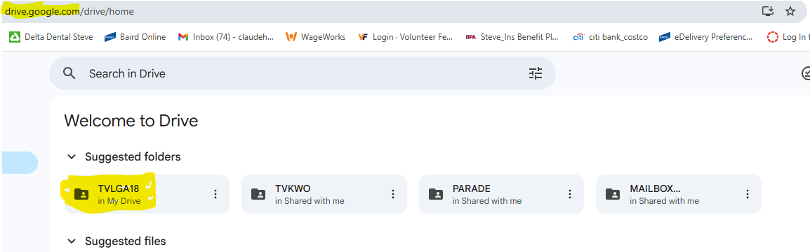

Double click on the TVLGA18 folder highlighted above to see all folders in our google drive.
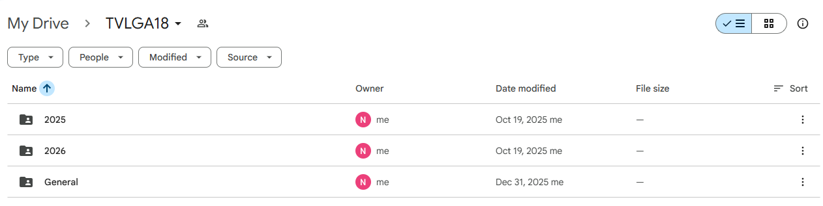

Double click on any of the folders to see the sub folders, if available. Below are the sub folders for the 2026 folder. Continue to double click on sub folders to view the documents.
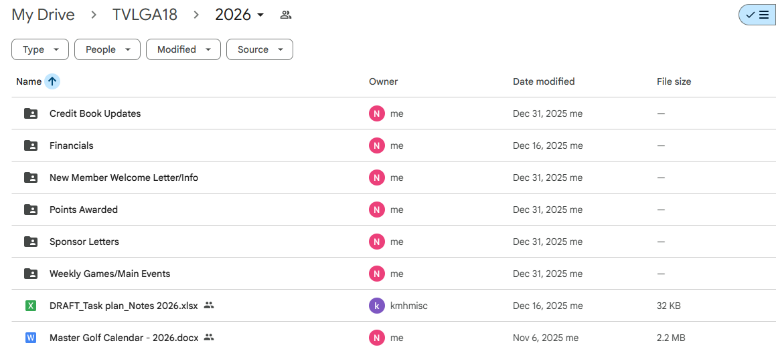

Add a new document to an existing or new folder. Drag and drop the document from an attachment or from your saved location as shown below. Or, click on the “new” button and click on File Upload.
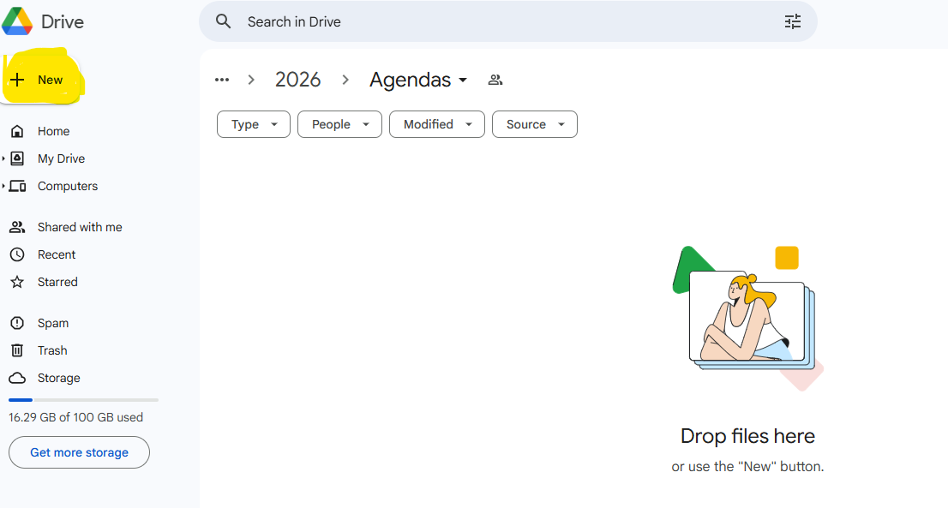

Once your document has been added to our Google drive, you can open it and make changes directly to that version. There is no need to make updates to an offline version and upload again.
Changes made to the documents are visible as they are being updated. No need to save.

